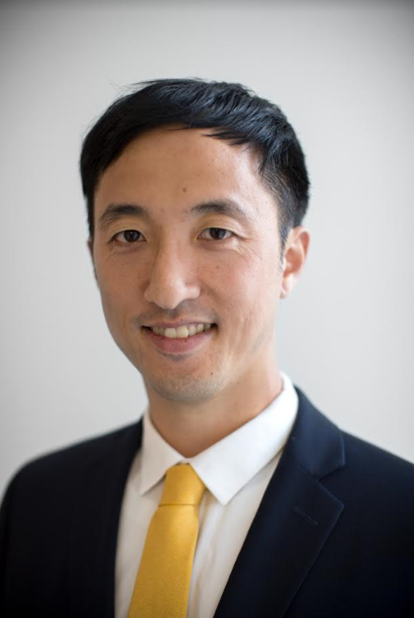

Paul Park, MD, MSc
Director of Implementation, NCD Synergies, Partners In Health
Associate Scientist, Brigham and Women's Hospital
Medical Officer, Indian Health Services

Dr. Park is an internal medicine physician and currently serves as the Director of Implementation for NCD Synergies at Partners In Health (PIH), where he focuses on designing, implementing, and evaluating novel community-based care models for non-communicable diseases in low-income countries. Paul's global health work began as an undergraduate volunteering for Timmy Global Health at Indiana University, and this continued through medical school. He would later spend six years living in East Africa, including Academic Model for Providing Access to Healthcare (AMPATH) in Kenya and PIH in Rwanda.

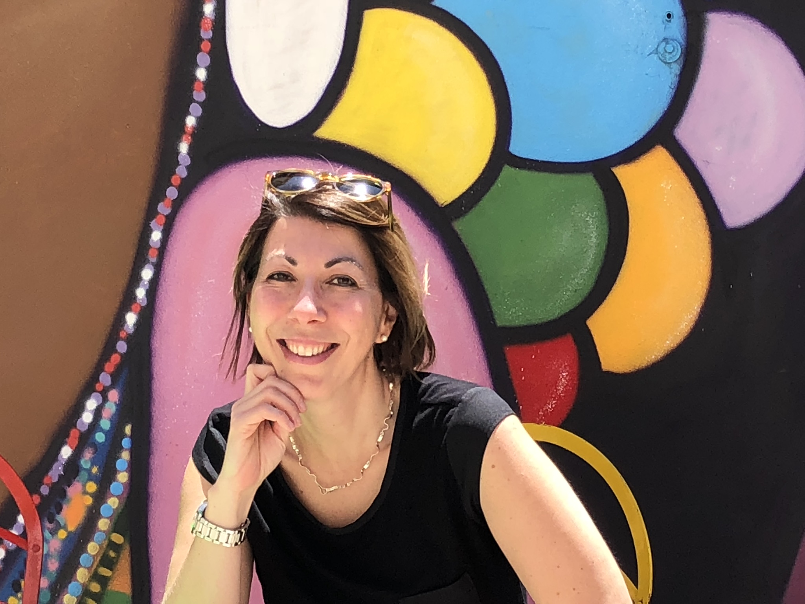

Laura Pompermaier, MD, PhD
Fellow, Program for Global Surgery and Social Change, Harvard Medical School

Dr. Pompermaier is originally from Italy, studied Medicine in Austria, and completed residencies in General Surgery, Plastic Surgery and Ph.D. studies in Sweden. She works as a consultant in Plastic Surgery in Sweden at Linköping University Hospital, where she is dedicated primarily towards surgical treatment of severe burn victims, genital reconstructive surgery and skin cancer surgery. She has worked in resource-poor settings as well, including clinical work as a voluntary surgeon in Kenya. Her research is focused on the role of Plastic Surgery in a global perspective. She is currently a Visiting Scholar at the Harvard Medical School’s Program for Global Surgery and Social Change.

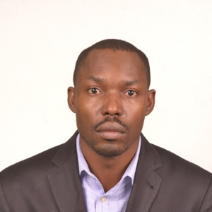

Christopher Millien, MD
Deputy Chief Medical Officer and Director of OBGYN, University of Mirebalais Hospital
Masters of Science in Global Health Delivery, Harvard Medical School

Dr. Millien’s is an expert in women's healthcare, patient care, advocacy for human rights, management, teaching, research, and establishment of OBGYN wards. He has been teaching social medicine and clinical skills for more than 5 years and was part of several research and quality improvement projects as co-author or principal instigator. He has been working in maternal health care for more than 14 years and has held various positions at “Zanmi La Sante,” the sister organization to the Boston-based Partners in Health.

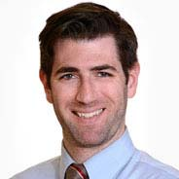

Jonathan Steer-Massaro, MD, MPH
Assistant Professor at Boston University School of Medicine

Dr. Steer did his residency in OBGYN at Boston Medical Center and received his MPH at the Harvard T.H. Chan School of Public Health. He is an academic generalist focusing on global health and medical education. His current practice focuses on inpatient obstetrics, colposcopy, and clinical and surgical gynecology. He has worked and taught OBGYN to trainees in Guyana, Kenya, and Lesotho.

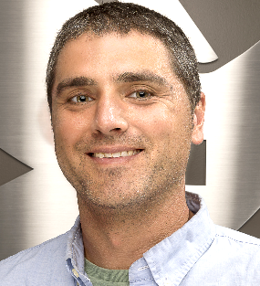

Ross Silkman, JD, MS
Senior Program Director, World Pediatric Project

Mr. Silkman currently serves as Senior Program Director with World Pediatric Project, overseeing International Teams activity and managing program efforts in the Eastern Caribbean region. Mr. Silkman focuses on program development and strategic planning aimed at tackling the challenges of building a tertiary healthcare delivery system to provide access to surgical care for all children in the small island developing states of the Eastern Caribbean.

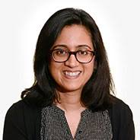

Manishi Desai, MD
Assistant Professor, Boston University School of Medicine

Dr. Desai is Assistant Professor in Ophthalmology specializing in glaucoma at Boston University School of Medicine. She is an alum of University of Illinois at Chicago residency program and completed her fellowship at University of Miami, Bascom Palmer Eye Institute. She spends majority of her time working with residents and fellows. As director of international education, she is currently working to build capacity in Lesotho, Africa. She is also serves as director of the glaucoma fellowship program for the ophthalmology department. Dr. Desai’s research areas focus on glaucoma care with current collaborations to evaluate visible light optical OCT in glaucoma. Recent other projects include focus on evaluating drop aids, early rise in intraocular pressure in patients after undergoing pterygium surgery, and ptosis in glaucoma surgery.

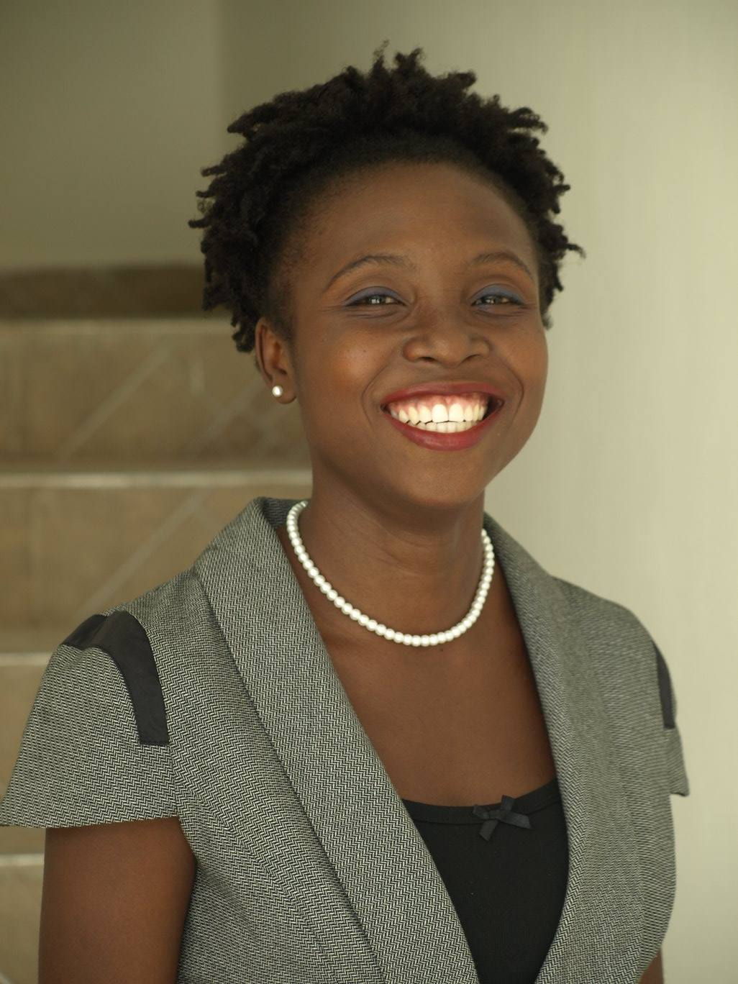

Laelle Mangurat, MD
General Surgeon, Providence of Gonaïves Hospital (HPG), Gonaïves, Haiti

Dr. Mangurat is a general surgeon and a graduate of the Faculty of Medicine and Pharmacy, School of Medical Biology, and Optometry of the State University of Haiti (FMP/EBO/UEH). She works as an attending physician and clinical instructor at Providence of Gonaïves Hospital in Gonaïves, Haiti, and as an assistant teacher in the anatomy department at her former medical school, FMP/EBO/UEH. Currently, she is a member of the Haitian Association of Surgery (ASHAC), Haitian Young Entrepreneurs Network (RJEH), Ethical Medicine and Society Laboratory (LABMES), and a founding member of “Sante Lakay,” Haitian Creole for “Home Health.” She has a passion for cardiothoracic and trauma surgery, teaching, research capacity building, and health systems strengthening.

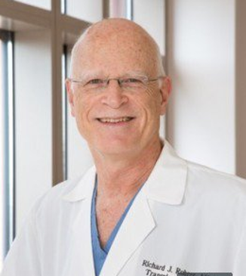

Rick Rohrer, MD
Professor of Surgery, Tufts University School of Medicine

Dr. Rohrer has had formative experiences in Global Health early in his career, in Africa and Southeast Asia. But after decades as a liver and kidney transplant surgeon in Boston, he turned his sights toward health care in underserved areas of Central and South America. He currently practices surgery part-time in Lowell, MA, and has roles with an NGO in Peru and the University of Panama Faculty of Medicine.

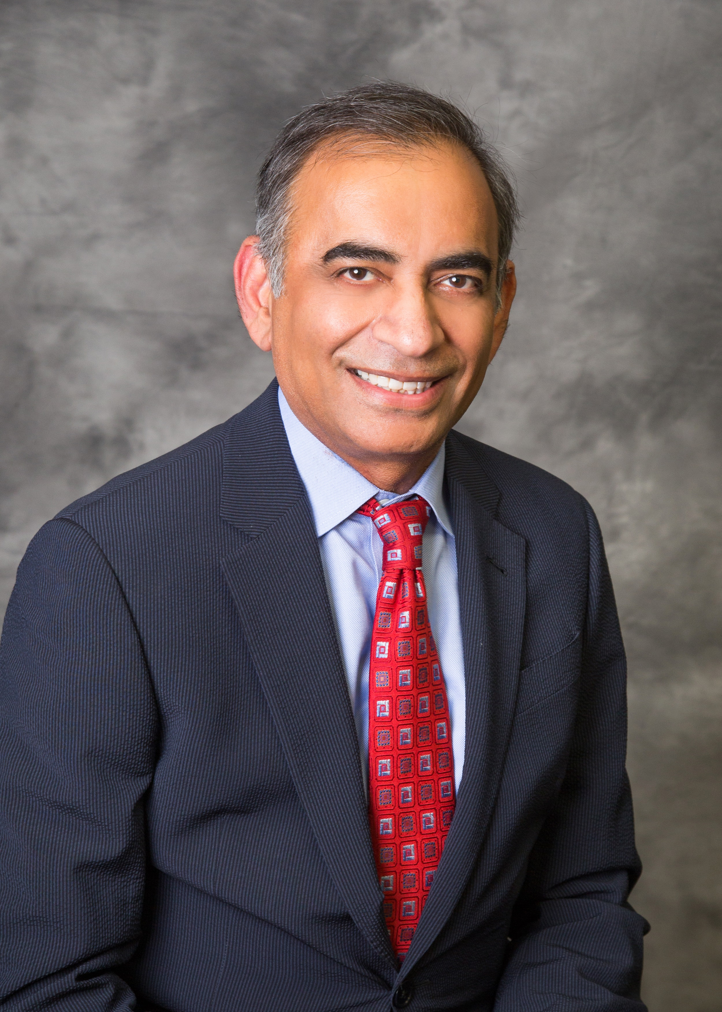

Jagdish Dhingra, MD
ENT Surgeon at ENT Specialists

Dr. Dhingra joined ENT Specialists in 2002. He attended the University College of Medical Sciences, Delhi University, Delhi, India, earning his medical degree in 1985. He did his initial surgical training in New Delhi, India (1985-1989), and subsequently in London, UK (1989-1996) before moving to the United States. He completed his residency training at Tufts Medical Center in Boston in 2002. In addition to his duties at ENT Specialists, Dr. Dhingra serves as Regional Residency Director and Clinical Assistant Professor at the Tufts University School of Medicine, Department of Otolaryngology. In 2004, Medical Missions for Children (MMFC) started a thyroid goiter surgery mission to Gitwe, a remote village in Rwanda, under the leadership of Dr. Dhingra, In May 2018, it completed its 13th annual mission.

Chuck Dietzen, MD
President & Founder, Timmy Global Health

“We’re not are all born to be doctors and nurses, but we were all born to be healers.”
A pediatric rehabilitation specialist, Dr. Dietzen is the Founder and President of Timmy Global Health, an Indianapolis-based nonprofit organization founded in 1997 to expand access to healthcare in the developing world, while empowering students and medical professional volunteers to tackle today’s most pressing global health challenges. Through its current work in Ecuador, Guatemala, Nigeria, and the Dominican Republic, Timmy Global Health seeks to strengthen community-based healthcare initiatives by educating and investing in partner organizations, providing financial support, and facilitating medical teams to serve communities on-the-ground. In addition to his work in global medicine, Dr. Chuck also Co-Founded iSalus Healthcare where he also served as Chief Medical Officer until it was purchased in January of 2019.

