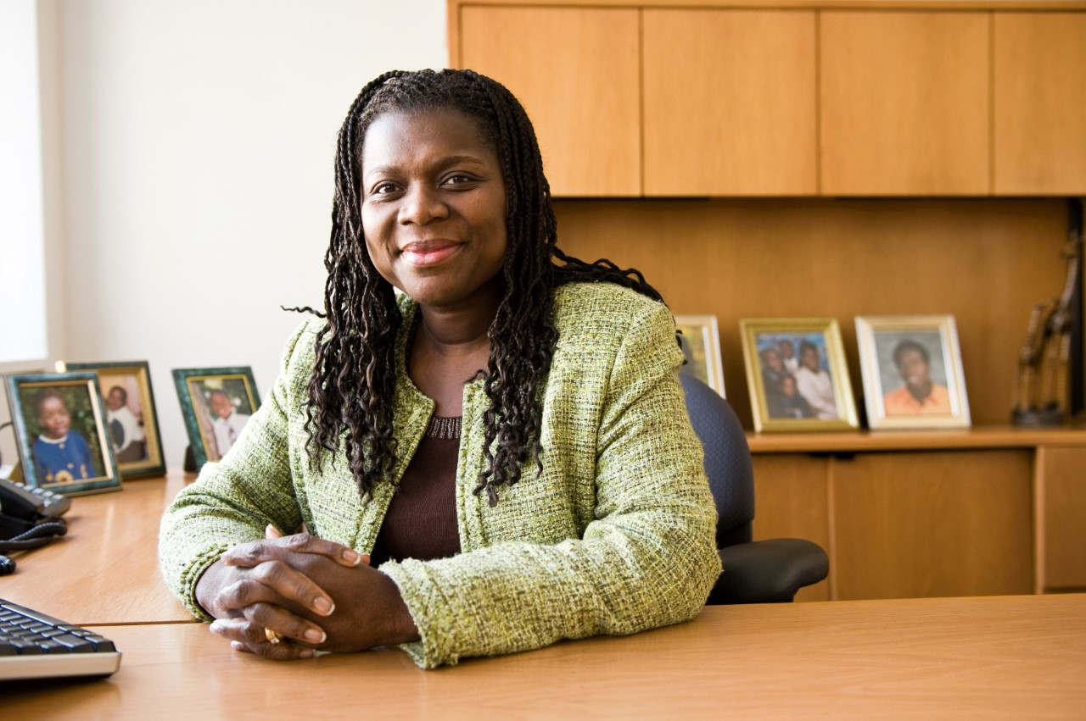

Joyce A. Sackey, MD
Dean for Multicultural Affairs and Global Health
Associate Provost and Chief Diversity Officer for Tufts University’s Health Sciences Schools

As TUSM’s Dean for Global Health, Dr. Sackey provides oversight for the School of Medicine’s global health programs and chairs the Global Health Faculty Council. She is also a member of the Provost Senior Leadership Team and serves as the Dean for Multicultural Affairs at TUSM, overseeing the school’s key diversity initiatives, including the development of the medical school’s Office for Multicultural Affairs pipeline programs, which recruit under-represented minority students at the high school, college, and post-graduate levels.

Dr. Sackey is a Dartmouth Medical School graduate and previously served as an Assistant Professor of Medicine and Associate Director for Oliver Wendell Holmes Society at Harvard Medical School. She was also an Attending Physician in Internal Medicine at Beth Israel Deaconess Medical Center, where she completed her residency and served as Primary Care Chief Resident. She completed her advanced fellowship training in medical education and served as a Senior Rabkin fellow in the Shapiro Institute for Education and Research at BIDMC and HMS.

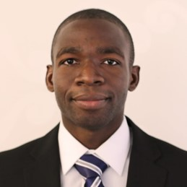

Ollie Osunkule, MD
Former Boston Consulting Group
M.B.A Candidate, Harvard Business School 2020

Dr. Osunkule attained his MD degree from the UK. Prior to starting at HBS, he worked as a consultant at the Boston Consulting Group in London, focused primarily on clients in the healthcare sector, including hospitals, biopharma and MedTech. Dr. Osunkule started his career as an academic-clinician in Oxford combining clinical work with research on sleep and eye disorders.

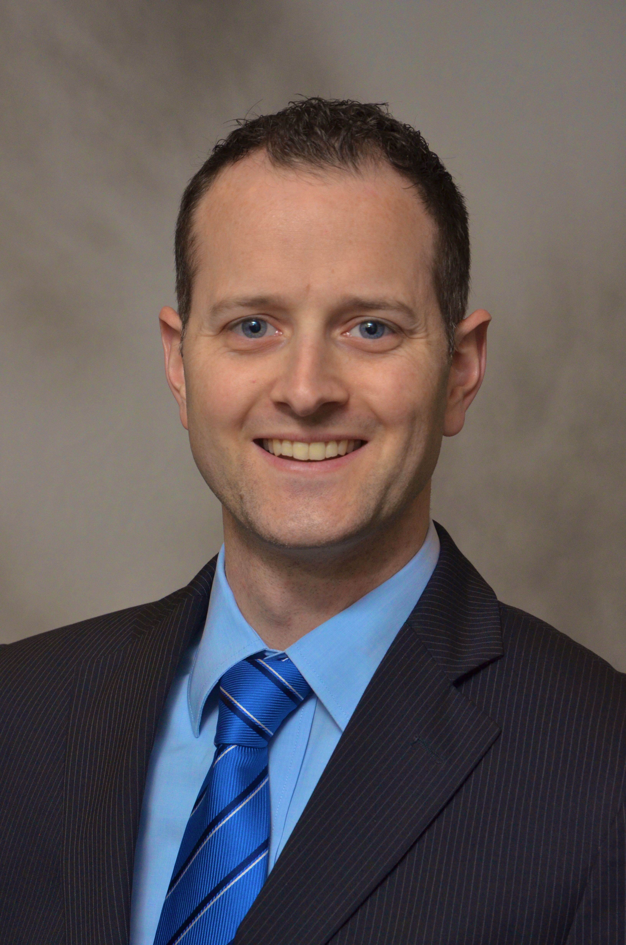

David A. Shaye, MD, MPH, FACS
Otolaryngologist/Head & Neck Surgeon, Massachusetts Eye & Ear Institute
Clinical Instructor at Harvard Medical School
Associate Head of Department, Central University Teaching Hospital, Kigali Rwanda

Dr. Shaye is a facial plastic and reconstructive surgeon with a split practice model between Mass Eye & Ear in Boston, and in Kigali Rwanda, where he serves as Associate Head of Department in Otolaryngology/Head & Neck Surgery. Dr. Shaye is a US State Department Fulbright Scholar who has a longstanding record of work in Zimbabwe establishing a cleft lip and palate care team, in Nepal developing a program for mobile surgical scouts that was featured on CNN's Vital Signs, and in Bhutan with their Ministry of Health on teaching facial trauma care. Dr. Shaye serves with Doctors Without Borders in Northern Nigeria as the surgical team leader for their Noma program. (Noma is a disfiguring disease of the face that afflicts malnourished children, mostly in Africa).

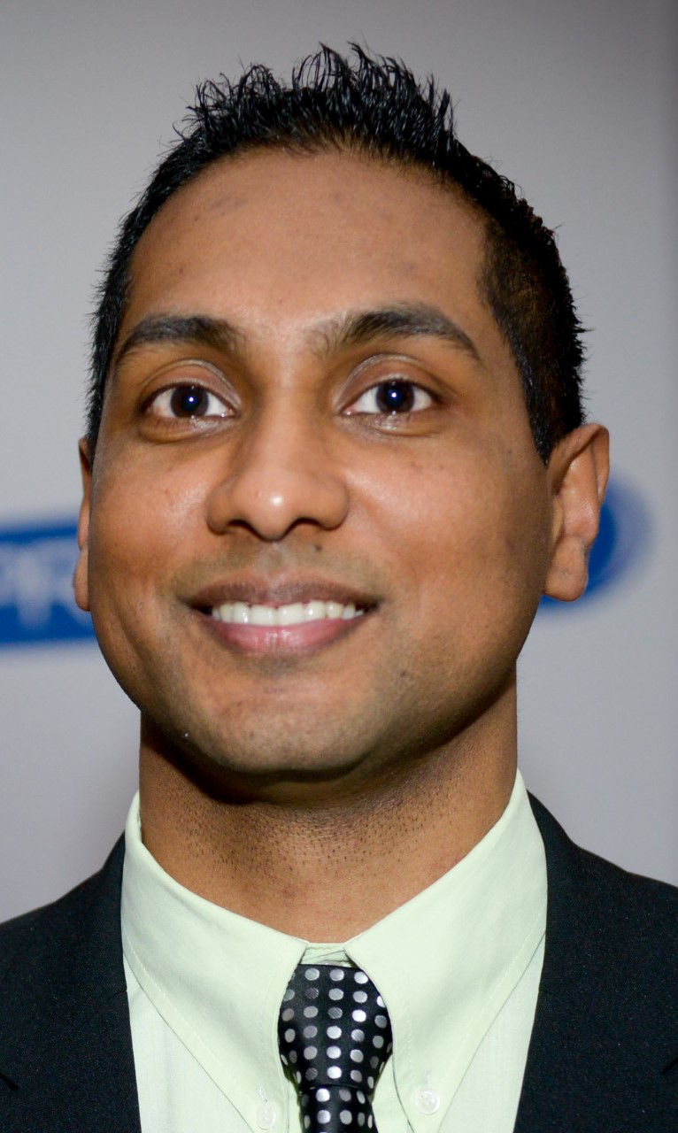

Sean Chetty, MbChB, CCH, DA, FCA
Head of the Clinical Department of Anesthesiology & Critical Care, Tygerberg Hospital, Stellenbosch University, Cape Town, South Africa

Dr. Chetty is a Specialist Anesthesiologist based at Stellenbosch University in Cape Town, South Africa. After completing his undergraduate medical degree at the University of Natal, he completed his post-graduate specialist training in Anesthesiology at the University of the Witwatersrand in Johannesburg. Dr. Chetty then went on to complete his subspecialty certificate in Critical Care before branching out into the field of Pain Medicine. He recently also completed his PhD at the University of the Witwatersrand. Dr. Chetty has devoted a considerable part of his career to improving the care of patients in sub-Saharan Africa. He has been involved in a number of practitioner training camps in the region. Dr. Chetty is currently the Africa representative on the Pain Committee of the World Federation of Societies of Anesthesiologists. His focus during his term has been to improve the pain management of patients in sub-Saharan Africa. Dr. Chetty is currently on sabbatical and working at the Department of Anesthesia, Critical Care and Pain Medicine at the Massachusetts General Hospital in Boston.

