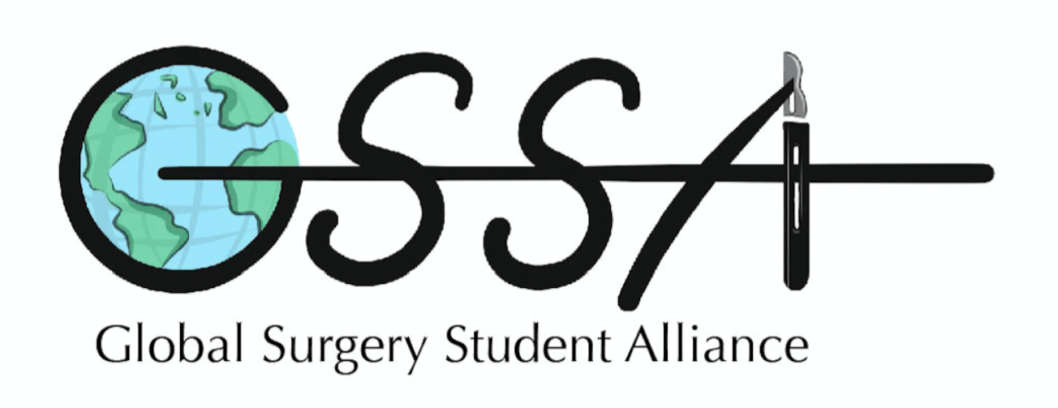
2nd Annual Northeast Global Surgery Hackathon
Mentor Schedule:
Rick Rohrer – Transplant Surgeon:
9am – 11am

Ross Silkman – Senior Program Director of the World Pediatric Project NGO:
8am – 10am

Maggie Towne – Global Health Research:
3pm – 5pm

Alice Tang – Public Health and Community Medicine with expertise in statistics:
3pm – 5pm

Alex Hannenberg – Anesthesia and Industry:
2pm – 5pm

Jonathan Steer – Assistant Professor, Department of Obstetrics and Gynecology, Boston University School of Medicine
12pm – 2pm

Stephen Okajima – Chief Technology Officer, Surgibox:
12pm – 2pm

Chuck Dietzen – Founder, Timmy Global Health NGO, health policy, industry:
8am – 12pm

Dr. Jinhui Peng – Pediatric Rehab Specialist:
8am – 12pm

